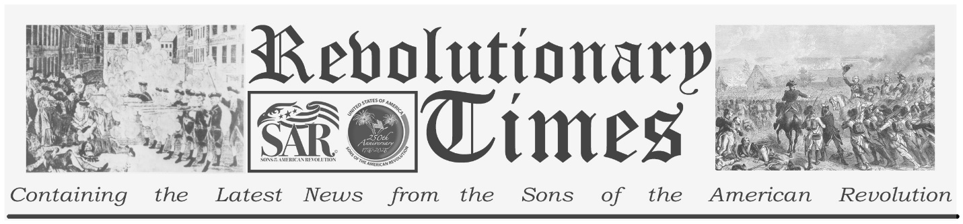

Signers of the Declaration of Independence

Carter Braxton
September 10, 1736-
October 10, 1797
Birthplace: Newington Plantation, Va.
Representing Virginia at the Continental Congress
Education: William and Mary College (Farmer)
Carter Braxton was born of a wealthy family in Newington Plantation Virginia. He lost nearly all his wealth in the course of the revolution, partly through his support of the Union, and partly through attack by the British forces.
He was educated at William and Mary College. He married at age 19, but his wife died about two years after. He then went to England for a little more than two years. In 1760 he returned, married again, and was appointed to represent King William county in the Virginia House of Burgesses. He was in attendance 1765, when Patrick Henry's Stamp Act resolutions agitated the Assembly. In 1769 he joined the "radical" faction of the Burgesses in support of Virginia's sole right to tax inhabitants. When the house was dissolved in 1774, he joined the patriot's Committee of Safety in Virginia, and represented his county in the Virginia Convention. In 1775, upon the sudden death of Peyton Randolph, Braxton was selected to assume his place in the Continental Congress.
He attended two years, after which he returned to Virginia to continue service to the House of Burgesses. During the War, he had loaned £10,000 sterling to support the revolutionary cause. He had also used his wealth to sponsor shipping and privateering during the conflict, the losses from which eventually resulted in debt. He never recovered, and, in 1786, was forced to leave his inherited country estate for simple quarters in Richmond. He died at age 61.
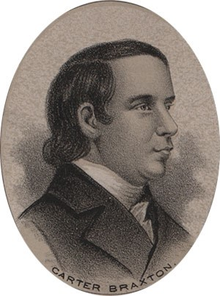
by Ole Erekson, Engraver, c1876, Library of Congress

This broadsheet is dedicated to the 250th Anniversary Celebration of the Declaration of Independence for more information visit the National Society Sons of the American Revolution website at: www.sar.org
Presented by: Oregon Sons of the American Revolution, www.oregonsar.org
Copyright © 1999-2023 by the Independence Hall Association, a nonprofit organization in Philadelphia, Pennsylvania, founded in 1942. Publishing electronically as ushistory.org. On the Internet since July 4, 1995. Source: www.ushistory.org

