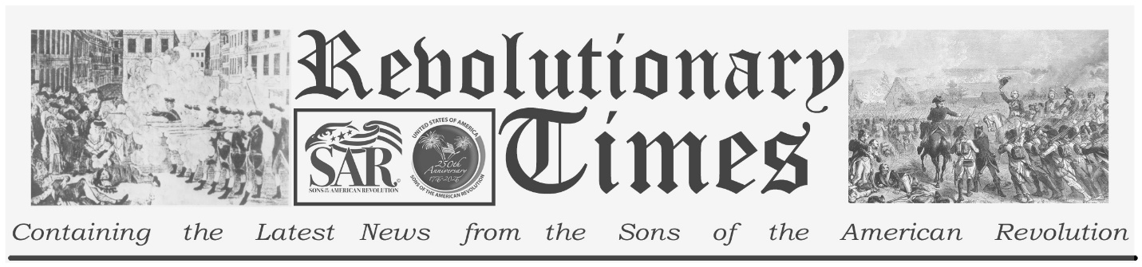

Signers of the Declaration of Independence

Josiah Bartlett
November 21, 1729-
May 19, 1795
Birthplace: Amesbury, Mass.
Representing New Hampshire at the Continental Congress
Education: Medicine (Physician, Judge)
Josiah Bartlett was born at Amesbury, Massachusetts, in November 1729. He studied medicine, and practiced as a physician at Kingston, in New Hampshire.
He became involved in politics and was elected a member of the Colonial Legislature. He was noted as a principled legislator, not susceptible to pressure from the Royal Governor, and as an active advocate against British oppression. He was a member of a Committee of Safety and served as commander of a militia regiment in 1775. In that year he was also elected to represent New Hampshire in the Continental Congress. He voted for independence, and was the first to sign the Declaration, after John Hancock. He continued to serve in 1777 and participated in the ratification of the Articles of Confederation.
He later filled the offices of Judge of Common Pleas and of the Supreme Court of his state and joined the federal Constitutional Convention in 1787. He was elected president, and then governor, of New Hampshire. He died May 19, 1795.
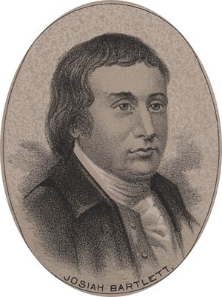
by Ole Erekson, Engraver, c1876, Library of Congress

This broadsheet is dedicated to the 250th Anniversary Celebration of the Declaration of Independence for more information visit the National Society Sons of the American Revolution website at: www.sar.org
Presented by: Oregon Sons of the American Revolution, www.oregonsar.org
Copyright © 1999-2023 by the Independence Hall Association, a nonprofit organization in Philadelphia, Pennsylvania, founded in 1942. Publishing electronically as ushistory.org. On the Internet since July 4, 1995. Source: www.ushistory.org

