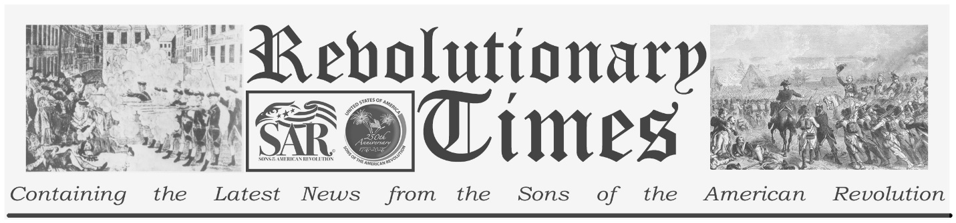

Signers of the Declaration of Independence

Elbridge Gerry

Jul. 17, 1744 –
November 23, 1814
Birthplace: Marblehead, Mass.
Representing Massachusetts at the Continental Congress
Education: Graduate of Harvard College (Merchant)
Elbridge Gerry was born in Marblehead, Massachusetts, on July 17, 1744. He studied at Harvard to be a merchant, graduating in 1762. He was elected to the Massachusetts Legislature in 1773 and was selected to attend the Provincial Congress in 1774. He was then appointed to the Continental Congress, where he was engaged in committee work on commercial and naval concerns. He attended the Constitutional Convention in 1787 but was opposed to the new Federal Constitution, refusing to sign it.
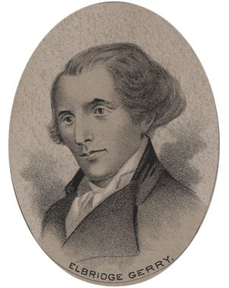
by Ole Erekson, Engraver, c1876, Library of Congress

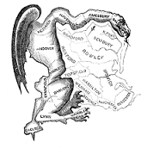
The Gerrymander
He was elected to the first two Congresses from Massachusetts and, in 1797, was one of several envoys sent to France. He was elected governor of Massachusetts in 1810 and 1811. He was much criticized for redistricting the state to the advantage of his own party (Democratic-Republican). A political cartoon that ran in the Boston Globe showed his strategically devised district map, which was shaped much like a salamander, along with the caption "The Gerrymander." The term is still used today to describe the unscrupulous practice of political incumbents devising electoral districts in such a way as to virtually assure their re-election. In 1812 he was elected Vice President of the United States. He died in office, on November 23, 1814, at the age of 70.

This broadsheet is dedicated to the 250th Anniversary Celebration of the Declaration of Independence for more information visit the National Society Sons of the American Revolution website at: www.sar.org
Presented by: Oregon Sons of the American Revolution, www.oregonsar.org
Copyright © 1999-2023 by the Independence Hall Association, a nonprofit organization in Philadelphia, Pennsylvania, founded in 1942. Publishing electronically as ushistory.org. On the Internet since July 4, 1995. Source: www.ushistory.org

