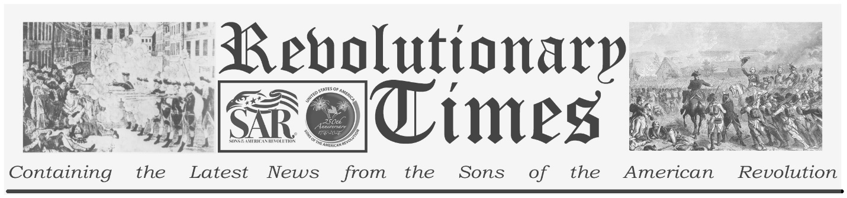

Signers of the Declaration of Independence

Benjamin Franklin
January 17, 1706- April 17, 1790
Birthplace: Boston, Ma.
Representing Pennsylvania at the Continental Congress
Education: Self-taught, apprenticed as a printer. Honorary Doctor of Laws, Universities of Edinburgh, and Oxford.
Benjamin Franklin, born in Boston, Massachusetts, on January 17, 1706, may by his life alone be the most profound statement of what an American strives to be.
With no formal education beyond the age of 10 years, Franklin was celebrated throughout Europe, welcomed in any Royal Court, sought out by every prestigious society. Indeed, when the reputations of George Washington and Thomas Jefferson had yet to be sorted out, Franklin was worshipped wherever his name was known.
He attended grammar school at age eight, but was put to work at ten. He apprenticed as a printer to his brother James, who printed the New England Courant, at age twelve, and published his first article there, anonymously, in 1721. Young Benjamin was an avid reader, inquisitive and skeptical. Through his satirical articles, he poked fun at the people of Boston and soon wore out his welcome, both with his brother and with the city. He ran away to New York and then on to Philadelphia at the age of 16, looking for work as a printer. He managed a commission to Europe for the purpose of buying supplies to establish a new printing house in Philadelphia but found himself abandoned when he stepped off ship. Through hard work and frugality he bought his fare back to Philadelphia in 1732 and set up shop as a printer. He was appointed clerk of the Pennsylvania Assembly in 1736, and as Postmaster the following year. In 1741 he began publishing Poor Richard's Almanac, a very popular and influential magazine. He was elected to the Pennsylvania Assembly in 1751 and served as an agent for Pennsylvania (and ultimately for three other colonies) to England, France, and several other European powers. He was elected to the Continental Congress in 1775, where he played a crucial role in the rebellion against Great Britain, including service to Jefferson in editing the Declaration of Independence. Franklin, who was by this time independently wealthy and retired from publishing, continued to serve an important role in government both local and national. He was the United States first Postmaster General, Minister to the French Court, Treaty agent and signer to the peace with Great Britain, Celebrated Member of the Constitutional convention (See Work, above). Benjamin Franklin: Businessman, Writer, Publisher, Scientist, Diplomat, Legislator, and Social activist, was one of the earliest and strongest advocates for the abolition of Slavery, and for the protection of the rights of American aboriginal peoples. He died on the 17th of April in 1790. On that day he was still one of the most celebrated characters in America. So should he always be.
Copyright © 1999-2023 by the Independence Hall Association, a nonprofit organization in Philadelphia, Pennsylvania, founded in 1942. Publishing electronically as ushistory.org. On the Internet since July 4, 1995. Source: www.ushistory.org

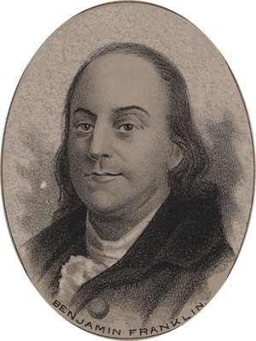
by Ole Erekson, Engraver, c1876, Library of Congress

This broadsheet is dedicated to the 250th Anniversary Celebration of the Declaration of Independence for more information visit the National Society Sons of the American Revolution website at: www.sar.org Presented by: Oregon Sons of the American Revolution, www.oregonsar.org

