The Connecticut Society of the Sons of the American Revolution
250th Anniversary of the First Continental Congress
(September 5, 1774 – October 26, 1774)
“We ask but for Peace, Liberty and Safety.”

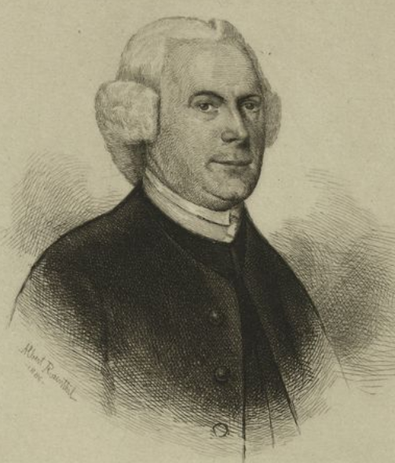

Patriot Grave Marking Ceremony for Connecticut Delegate
Eliphalet Dyer (1721-1807)

Saturday October 12, 2024 - 1:00 PM
Windham Center Cemetery
219 Windham Center Road (Route 203)
Windham, Connecticut 06280
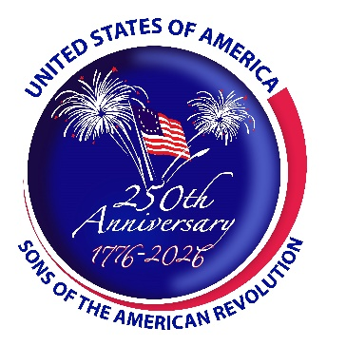

Annual Meeting of the Gov. Jonathan Trumbull Branch #13 CTSSAR

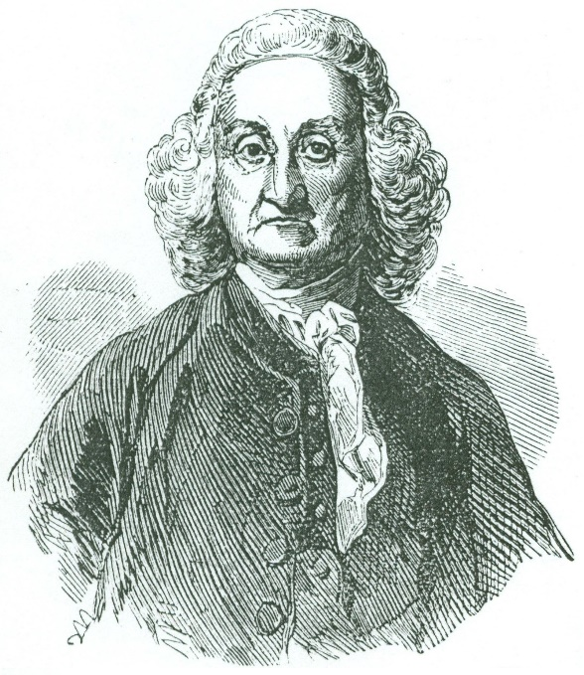

Saturday October 12, 2024 - 10:00 AM
War Office
149 West Town Street, Lebanon, Connecticut 06249

CTSSAR Property Steward’s War Office Report

~ Unveiling of a 250th Anniversary of the American Revolution Project ~

Happy Birthday Governor Jonathan Trumbull
314th Birthday Ceremony for
Connecticut’s Revolutionary War “Rebel Governor”
Jonathan Trumbull (born October 12, 1710)
The only patriot governor to serve prior to, during, and after the American Revolution
(1769-1784)

“A long and well spent life in the service of his country justly entitled
him to the first place among patriots.” - George Washington, October 1, 1785

* It’s a 10 to 15 minute drive from the War Office to Windham Center Cemetery *

Special Thanks

The Society of the Cincinnati in the State of Connecticut, The Connecticut Museum of Culture and History, Capture Visual Marketing, The Town of Windham, The Connecticut Society of the Sons of the American Revolution and its Historic Sites & Celebrations – America 250 Committee and Properties Committee, The Connecticut Daughters of the American Revolution.

The granite SAR patriot marker for Eliphalet Dyer was made possible by the financial contribution of Compatriot David Perkins.
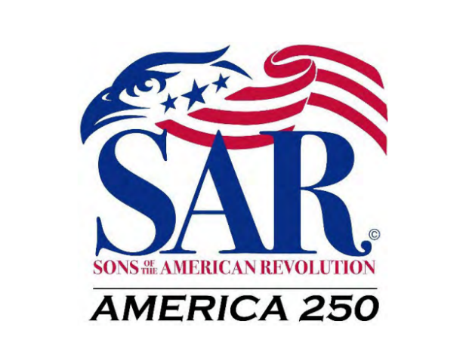

About the America 250
Projects of the Sons of the American Revolution

The America 250 SAR Project Committee members work on the national, state, and local levels to promote the commemoration of the 250th Anniversary of the American Revolution and the establishment of the United States. It designs commemorative merchandise and SAR member insignia for the anniversary. This committee publicizes the anniversary using media, education, and government contacts. The 250th Anniversary Committee helps develop educational programs and booklets relating to the American Revolution, encourages the internationally focused SAR societies (including the Canada SAR, France SAR, Germany SAR, International SAR, Mexico SAR, Spain SAR, Switzerland SAR, and United Kingdom SAR) to plan special Congresses during the celebrations, and works with other SAR committees to coordinate celebration of the 250th anniversary.
For more information on the America 250 SAR program: www.america250sar.com
For more information on the National Society Sons of the American Revolution: www.sar.org
For more information on the Connecticut Society of the Sons of the American Revolution and our calendar of SAR America 250 events please visit our website at: www.SARconnecticut.org

