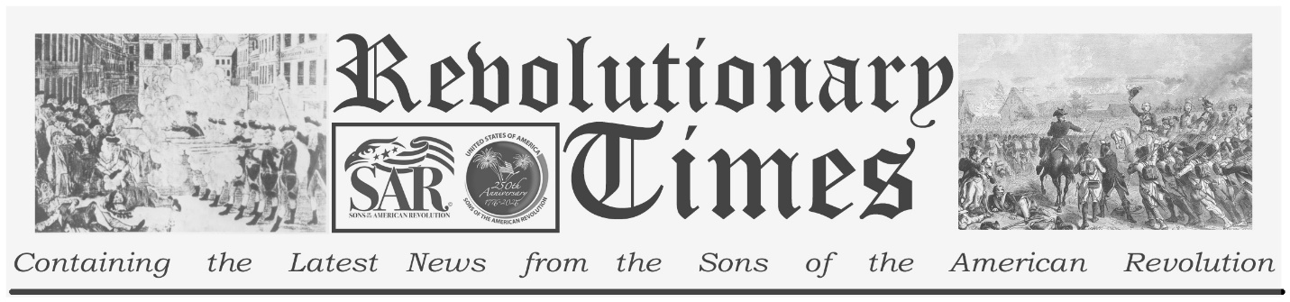

Signers of the Declaration of Independence

Button Gwinnett
circa 1732-1735 - May 19, 1777
Birthplace: Down Hatherly, England
Representing Georgia at the Continental Congress
Education: Mercantile.
Button Gwinnett was born in England around 1735. He came to America, residing briefly in Charleston, and in 1765 acquired a large tract of land in Georgia. Gwinnett enjoyed little success in farming or business but found a footing in the revolutionary politics of his adopted colony. He was engaged in a long-standing political rivalry with Lachlan McIntosh, a soldier and leader who would attain highest rank in the Georgia militia and in state politics. Gwinnett was respected figure, however. In 1776 he was appointed commander of Georgia's continental militia (a post that he was forced to decline, owing to political faction), and also elected to attend the Continental Congress. Quite soon after he signed the Declaration, he returned home, where he hoped to gain appointment, once again, to the leadership of the Georgia militia. The appointment went instead to his rival. Gwinnett served in the Georgia legislature where he was involved in drafting a constitution for the new state, but also in strenuous efforts to destroy the office of McIntosh. The legislature adjourned in February of 1777 and handed control over the Council of Safety. Gwinnett succeeded Archibald Bulloch as president of the council soon afterward. He then led an abortive attempt to invade Florida, in order to secure Georgia's southern border. That adventure was thwarted by Lachlan McIntosh and his brother George, and Gwinnett was charged with malfeasance. He was cleared of wrongdoing as he ran an unsuccessful campaign for Governor. Soon afterward, his honor challenged in public by McIntosh, he offered a duel. They met outside of Savanna on May 16, 1777, where both were wounded. McIntosh ultimately survived; Button Gwinnett died three days later at the age of 42.
Copyright © 1999-2023 by the Independence Hall Association, a nonprofit organization in Philadelphia, Pennsylvania, founded in 1942. Publishing electronically as ushistory.org. On the Internet since July 4, 1995. Source: www.ushistory.org

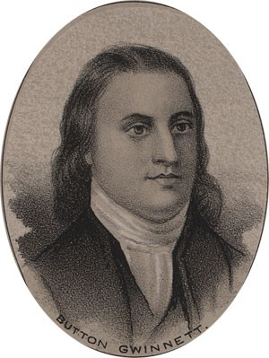
by Ole Erekson, Engraver, c1876, Library of Congress

This broadsheet is dedicated to the 250th Anniversary Celebration of the Declaration of Independence for more information visit the National Society Sons of the American Revolution website at: www.sar.org Presented by: Oregon Sons of the American Revolution, www.oregonsar.org

