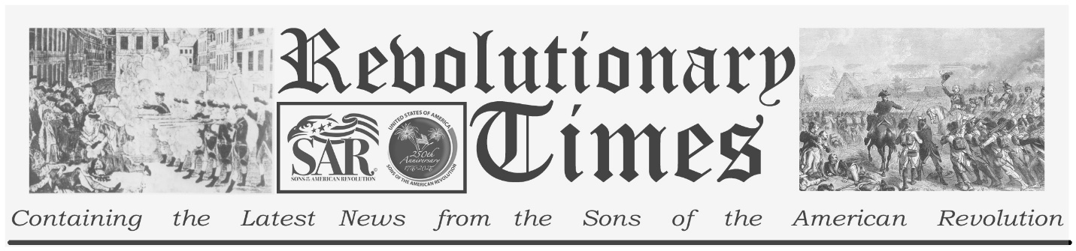
Major General Philip Schuyler

Philip Schuyler
Born November 20, 1733
Died November 18, 1804
Birthplace: Albany, New York.
Commander of the Northern Department of New York

Philip Schuler was educated in public school and tutored by aristocrats. He learned to speak Mohawk from Iroquois trade leaders.
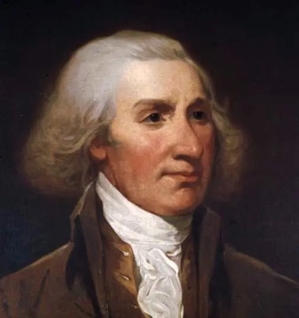
In 1775 he joined the British forces during the French and Indian War which prepared him militarily. He mastered tactics and logistics in his position as quartermaster, In 1775, Schuyler began his political career which would span decades. In between the wars he would become one of the wealthiest landholders in the region. He was a delegate to the Continental Congress and was placed on a committee with George Washington to draw up rules for the Army. In June of 1775, Schuyler was appointed one of the first four Major Generals of the Continental army by the Continental Congress. In 1777 he was assigned to command the Continental Army’s Northern department of New York. He immediately was difficult task of organizing as army for the invasion of Canada
and to prepare a defense against a British invasion which would become known as “The Saratoga Campaign.” Schuyler would proceed to Fort Ticonderoga and establish his headquarters where he would dig in and prepare a defense with 2900 untrained and poorly supplied troops. Conditions were so poor that he would beg to congress for 4500 additional men. Before leaving for Albany for the winter, he makes arrangements that would help facilitate the removal of cannons, artillery, and military stores by Henry Knox, Those weapons would be used to drive the British out of Massachusetts and end the Siege of Boston. During the invasion of Canada, plans were made for a two pronged attack with Schuyler’s army to first take Montreal after which, he would then move north to Quebec and attack from the south. Meanwhile, General Benedict Arnolds army would surprise the British by attacking from the east. Unfortunately, logistical delays and health issues of gout and pleurisy plagued Schuyler, and he was forced to turn his field command over to Brigadier General Richard Montgomery who would lead the troops to a victory at Montreal. However, with troop strength epleted after expiring enlistment contracts, Montgomery and Arnolds nighttime attack on Quebec was a complete disaster culminating in the death of General Montgomery, and leaving General Arnold badly wounded. The British would also take 400 Patriots prisoner. This disastrous failure would prompt Schuyler taking the blame for the defeat and calls for his removal of command even thought he was not there. The British invasion began on July 6, 1777 with British General John Burgoyne’s siege of Fort Ticonderoga. Due to the lack of troops, Schuyler made plans to evacuate and slow down the invasion with barricading the narrow roadway with fell trees.
The uncontested surrender would cause Schuyler to be relieved of his command and Court Martialed But, he would later be exonerated however, his military service would be tainted from this unfortunate set of circumstances. Even though exonerated, he would resign from the Army in April 1779 and go on to serve in the New York General assembly and two terms in the United State Senate until January 3, 1798.

This broadsheet is dedicated to the 250th Anniversary Celebration of the Declaration of Independence for more information visit the National Society Sons of the American Revolution website at: www.sar.org Presented by: Oregon Sons of the American Revolution, www.oregonsar.org

