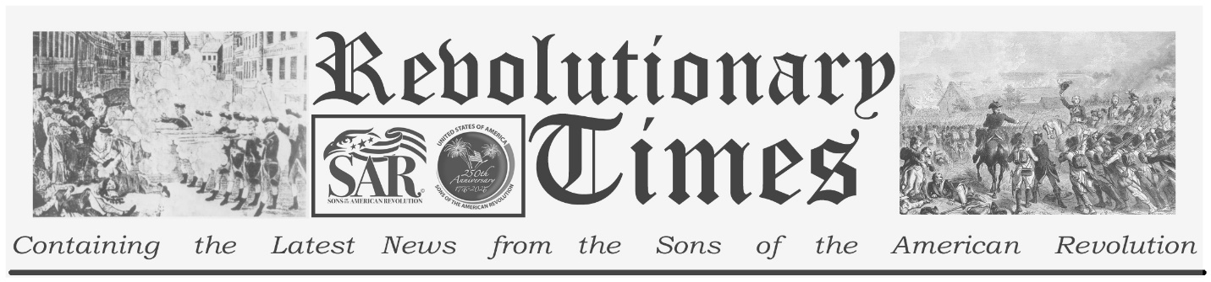

Signers of the Declaration of Independence

John Adams
October 30, 1735- July 4, 1826
Birthplace: Braintree, Mass.
Representing the colony of Massachusetts at the Continental Congress
Education: Graduate of Harvard. (Lawyer)

Adams began his education in a common school in Braintree. He secured a scholarship to Harvard and graduated at the age of 20.
He apprenticed to a Mr. Putnam of Worcester, who provided access to the library of the Attorney General of Massachusetts and was admitted to the Bar in 1761. He participated in an outcry against Writs of Assistance. Adams became a prominent public figure in his activities against the Stamp Act, in response to which he wrote and published a popular article, "Essay on the Canon and Feudal Law." He was married on Oct. 25, 1764, and moved to Boston, assuming a prominent position in the patriot movement. He was elected to the Massachusetts Assembly in 1770 and was chosen one of five to represent the colony at the First Continental Congress in 1774.
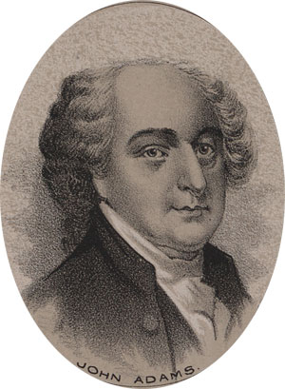
by Ole Erekson, Engraver, c1876, Library of Congress

Again in the Continental Congress, in 1775, he nominated Washington to be commander-in-chief on the colonial armies. Adams was a very active member of congress; he was engaged by as many as ninety committees and chaired twenty-five during the second Continental Congress. In May of 1776, he offered a resolution that amounted to a declaration of independence from Great Britain. He was shortly thereafter a fierce advocate for the Declaration drafted by Thomas Jefferson. Congress then appointed him to replace Silas Dean as a diplomat at the French court. He returned from those duties in 1779 and participated in the framing of a state constitution for Massachusetts, where he was further appointed Minister plenipotentiary to negotiate a peace, and form a commercial treaty, with Great Britain. In 1781 he participated with Franklin, Jay and Laurens, in development of the Treaty of Paris and was a signer of that treaty, which ended the Revolutionary War, in 1783.
Copyright © 1999-2023 by the Independence Hall Association, a nonprofit organization in Philadelphia, Pennsylvania, founded in 1942. Publishing electronically as ushistory.org. On the Internet since July 4, 1995. Source: www.ushistory.org

He was elected Vice President of the United States under George Washington in 1789 and was elected President in 1796. Adams was a Federalist, and this made
him an arch-rival of Thomas Jefferson and his Republican party. The discord between Adams and Jefferson surfaced many times during Adams' (and, later, Jefferson's) presidency. This was not a mere party contest. The struggle was over the nature of the office and on the limits of Federal power over the state governments and individual citizens. Adams retired from office at the end of his term in 1801. He was elected President of a convention to reform the constitution of Massachusetts in 1824 but declined the honor due to failing health.
He died on July 4, 1826 (incidentally, within hours of the death of Thomas Jefferson.) His final toast to the Fourth of July was "Independence Forever!" Late in the afternoon of the Fourth of July, just hours after Jefferson died at Monticello, Adams, unaware of that fact, is reported to have said, "Thomas Jefferson survives."

This broadsheet is dedicated to the 250th Anniversary Celebration of the Declaration of Independence for more information visit the National Society Sons of the American Revolution website at: www.sar.org
Presented by: Oregon Sons of the American Revolution, www.oregonsar.org

