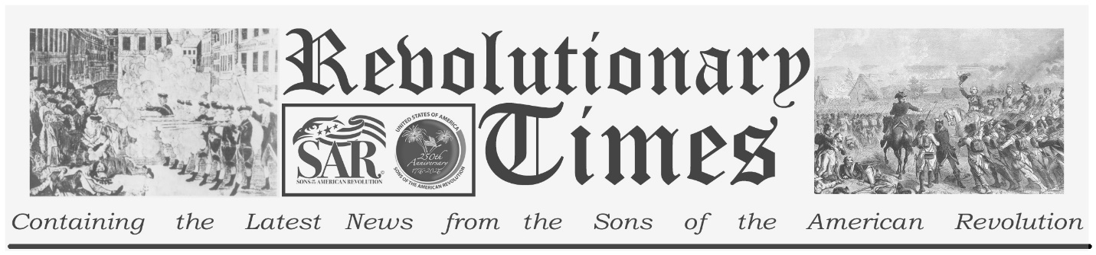

Signers of the Declaration of Independence

William Floyd
December 17, 1734-
August 4, 1821
Birthplace: Brookhaven, N.Y.
Representing New York at the Continental Congress
Education:
William Floyd was born on Long Island on December 17, 1734. His family had emigrated to America in 1654 and by the time of his birth were well established and wealthy. Though he might have received the best education, his father died when he was in his teens, and William was required to take over the operations of the family farm. He was a member of the Suffolk County Militia in the early conflict with Britain, attaining the rank of Major General.
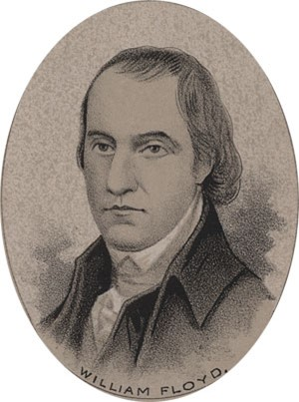
by Ole Erekson, Engraver, c1876, Library of Congress

In 1774 he was chosen to represent New York in the first Continental Congress. He served there through 1776, while his property was destroyed in the Revolutionary War. He acquired land on the banks of the Mohawk river after the war though it would be a few more years till he would retire there. In 1789 he was elected to the 1st Congress under the new Constitution, serving until 1791. In 1792 he served as a presidential elector, voting for the re-election of George Washington. He was called to the service of his state as a Senator in 1803. After serving his term he retired to his true passion, farming. He died in 1821.

This broadsheet is dedicated to the 250th Anniversary Celebration of the Declaration of Independence for more information visit the National Society Sons of the American Revolution website at: www.sar.org
Presented by: Oregon Sons of the American Revolution, www.oregonsar.org
Copyright © 1999-2023 by the Independence Hall Association, a nonprofit organization in Philadelphia, Pennsylvania, founded in 1942. Publishing electronically as ushistory.org. On the Internet since July 4, 1995. Source: www.ushistory.org

