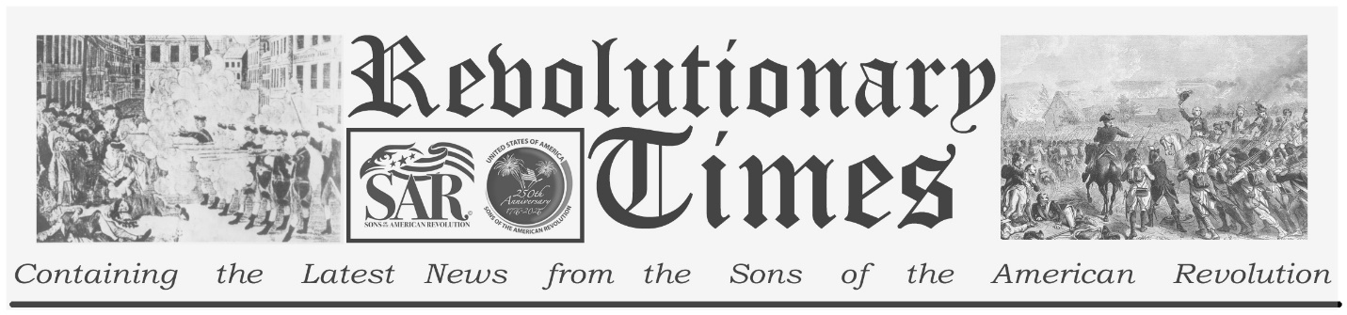

Commander in Chief George Washington

George Washington
Born February 22, 1732
Westmoreland County Virginia
Died December 14, 1799
Mount Vernon Virginia
Commander Continental Army
President of the United States

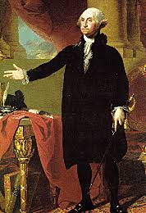
George Washington was chosen Commander in Chief by the Second Continental Congress in 1775 for his military experience; they also appointed four Major Generals to support and help lead the fledgling Colonial Army. An army made up of men who came to America from across the globe and spoke 38 different languages and were diverse in faith, education and military ability.

Washington and his generals had the nearly impossible task of forming an army to defeat the strongest, most experienced military force in the world. The following officers were the four Major Generals assigned to serve under Washington:

Artemas Ward Massachusetts
Israel Putnam Connecticut
Philip Schuyler New York Charles Lee Virginia

A hero of the American Revolution, Washington is acclaimed for his daring surprise attack on British-aligned Hessian mercenaries on Christmas evening 1776. Led by Washington himself, the Continental Army triumphed by crossing the icy Delaware River and attacking the enemy camp in Trenton, New Jersey following the deadly winter encampment at Valley Forge. Washington personally led 17 major battles of the Revolutionary War, the most significant being the Battle of Yorktown.

Washington had several characteristics, long before he was Commander in Chief, that contributed to his leadership style. He was known for his patience, drive, attention to detail, strong sense of responsibility, and firm moral conscience. All of these characteristics drew people to him and contributed to their trust in him. Washington mentored his young generals, drawn from all walks of life, as a father would and produced an unorthodox leadership team that surprised the world.

This broadsheet is dedicated to the 250th Anniversary Celebration of the Declaration of Independence for more information visit the National Society Sons of the American Revolution website at: www.sar.org
Presented by: Missouri SAR
Ozark Mountain Chapter

